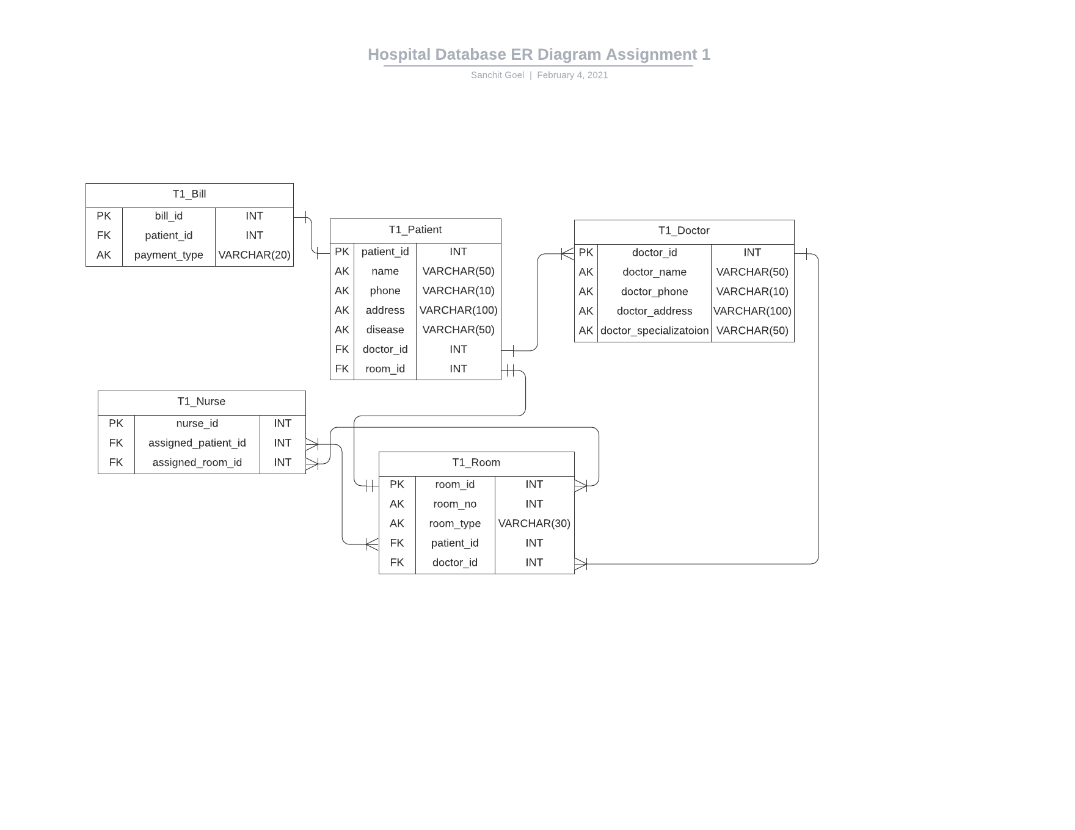

There is no weak entity since every entity has an id attribute acting as the primary key.
This diagram is made using lucid chart. I used lucid chart because there ui is really good.
Link to the diagram: https://lucid.app/lucidchart/invitations/accept/71cc526c-f462-4016-b3c8-2e4139065d46
If you want me to stop using this software, I’ll then change my software to mysql workbench.

